**OpenAI's GPT-3.5-turbo-instruct Model**

OpenAI's **GPT-3.5-turbo-instruct** is a powerful language model designed to understand and generate human-like text based on the input it receives. Earlier model is another model was there now it was deprecated.this model benefits is evolution of the original offering improved performance, context handling, and instruction-following capabilities.

**Features:**

1 Advanced Language Understanding: It can comprehend complex instructions and generate contextually relevant text.

2 .Versatile Applications: Suitable for a wide range of applications, including text generation, summarization, question-answering, and more.

3 Improved Efficiency: Enhanced performance in generating coherent and contextually appropriate responses.

**Contextual Adaptability:** GPT-3.5-turbo-instruct is better at maintaining context over longer interactions, ensuring coherent and contextually appropriate responses even in extended conversations

**Resource Management:** Enhanced efficiency in processing allows for better resource utilization, which is crucial for large-scale deployments.

### **LangChain**

LangChain is a framework designed to facilitate the development of applications that use language models (LLMs). It provides a structured way to manage prompts, connect to various LLM providers, and chain together different components to build complex workflows.

**Key Components:**

* **Prompt Templates:** Standardized templates that help in crating prompts for LLMs.
* **Chains:** A way to link multiple steps or models together, allowing for complex processing pipelines.
* **Integration with Multiple LLMs:** LangChain can connect with various language models, including OpenAI, to leverage their capabilities.

**Usage in Application:** For the about page content generation,

**1. Prompt Template Creation**

created a prompt template that specifies the format and style of the content required for the about page. This ensures consistency and quality in the generated content.

#### **2. Connecting with LLMs**

LangChain allows us to connect to different LLMs, including OpenAI's models. This flexibility enables you to choose the best model for your specific use case.

#### **3. Chain Creation**

created a chain using LangChain that links the prompt template with the LLM. This chain encapsulates the entire process, from crafting the prompt to generating the content, ensuring a seamless workflow.

#### **4. Execution and Response**

By running the chain, it could generate the about page content efficiently. LangChain handles the interactions with the LLM, manages the prompt, and retrieves the generated text

ALL the validate call here below

**src/utils/utils.py**

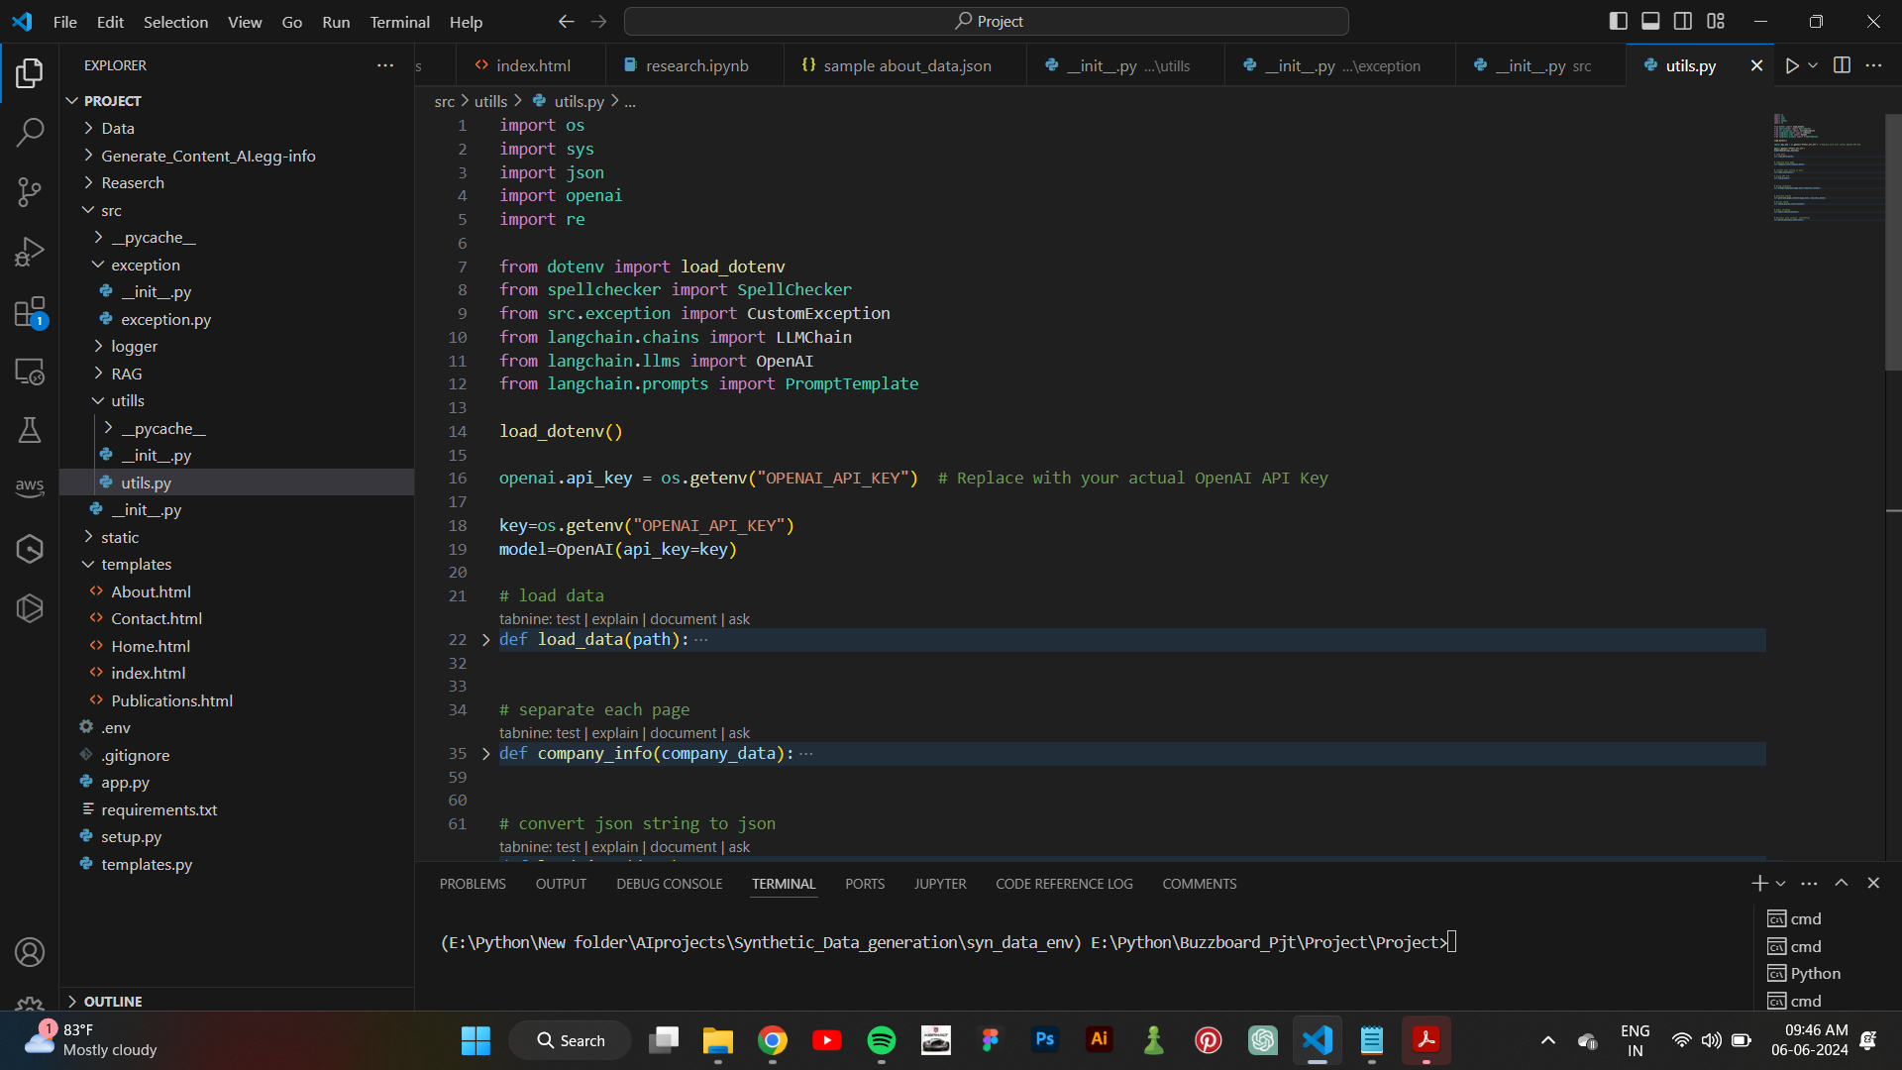

**Flaskapi**

**app.py**



